SET-01
1.Write a Pandas program to select the distinct department id from employees file.
code:
import pandas as pd
df = pd.read_csv("employees.csv")
print("Distinct Department IDs:")
print(df["department_id"].drop_duplicates())
output:
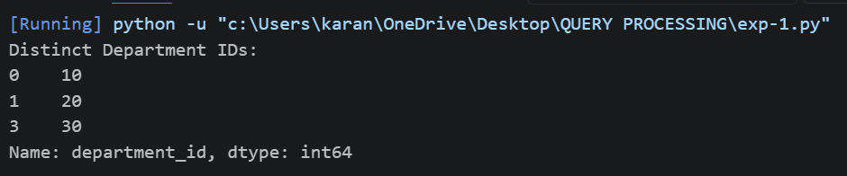
2. Write a Pandas program to display the IDs of employees who have done two or more
Code:
import pandas as pd
df = pd.read_csv("jobhistory.csv")
result = df.groupby("employee_id").size()
print("Employees with two or more jobs:")
print(result[result >= 2])
Output:
